DEAD CODE ELIMINATION
Aim
To write and implement a C program to identify and eliminate dead code from a given sequence of Three Address Code (TAC) statements and display the optimized code.

Algorithm
- Start the program.
- Declare arrays to store TAC statements, left-hand-side variables, right-hand-side expressions, and live statements.
- Read TAC statements from the user until END is entered.
- Separate each statement into its left-hand-side variable and right-hand-side expression.
- Scan the statements in reverse order.
- Identify variables whose values are required by live statements.
- Mark the statements that produce required results as live.
- Remove statements whose results are never used.
- Display the optimized Three Address Code.
- Stop the program.

Pseudocode

BEGIN
DECLARE code, lhs, rhs
DECLARE live[MAX] = 0
SET n = 0

PRINT "Enter Three Address Code"
PRINT "Enter END to finish"

WHILE input is available
READ line

IF line = "END"
BREAK
END IF

STORE line in code[n]
SEPARATE line into lhs[n] and rhs[n]
INCREMENT n
END WHILE

FOR i = n-1 DOWN TO 0

IF statement has no assignment
MARK statement as live
CONTINUE
END IF

SET needed = 0

CHECK whether lhs[i] is used
by any later live statement

IF needed = 1
MARK statement as live
END IF

IF lhs[i] is an output variable
MARK statement as live
END IF

IF statement is live
FIND variables used in rhs[i]
MARK their earlier definitions as live
END IF

END FOR

PRINT "Optimized Three Address Code"

FOR i = 0 TO n-1
IF live[i] = 1
PRINT code[i]
END IF
END FOR

STOP
Program
#include <stdio.h>
#include <string.h>
#include <ctype.h>

#define MAX 100
#define LEN 100

int main()
{
char code[MAX][LEN];
char lhs[MAX][LEN];
char rhs[MAX][LEN];
int live[MAX] = {0};
int n = 0, i, j;
char line[LEN];

printf("Enter Three Address Code statements.\n");
printf("Enter END to finish:\n");

while (n < MAX && fgets(line, sizeof(line), stdin))
{
line[strcspn(line, "\n")] = '\0';

if (strcmp(line, "END") == 0)
break;

if (strlen(line) == 0)
continue;

strcpy(code[n], line);

char *equal = strchr(line, '=');

if (equal != NULL)
{
*equal = '\0';

sscanf(line, "%99s", lhs[n]);
strcpy(rhs[n], equal + 1);
}
else
{
lhs[n][0] = '\0';
rhs[n][0] = '\0';
}

n++;
}

for (i = n - 1; i >= 0; i--)
{
if (lhs[i][0] == '\0')
{
live[i] = 1;
continue;
}

int needed = 0;

for (j = i + 1; j < n; j++)
{
if (live[j] && strcmp(lhs[i], lhs[j]) == 0)
{
needed = 1;
break;
}
}

if (needed)
live[i] = 1;

if (strcmp(lhs[i], "x") == 0 ||
strcmp(lhs[i], "y") == 0)
{
live[i] = 1;
}

if (live[i])
{
char *p = rhs[i];

while (*p)
{
if (isalpha((unsigned char)*p) || *p == '_')
{
char var[LEN];
int k = 0;

while (isalnum((unsigned char)*p) ||
*p == '_')
{
var[k++] = *p++;
}

var[k] = '\0';

for (j = i - 1; j >= 0; j--)
{
if (strcmp(lhs[j], var) == 0)
{
live[j] = 1;
break;
}
}
}
else
{
p++;
}
}
}
}

printf("\nOptimized Three Address Code:\n");

for (i = 0; i < n; i++)
{
if (live[i])
printf("%s\n", code[i]);
}

return 0;
}
Sample Input
t1 = a + b
t2 = c * d
t3 = t1 + 10
x = t3
y = 20
END

Output

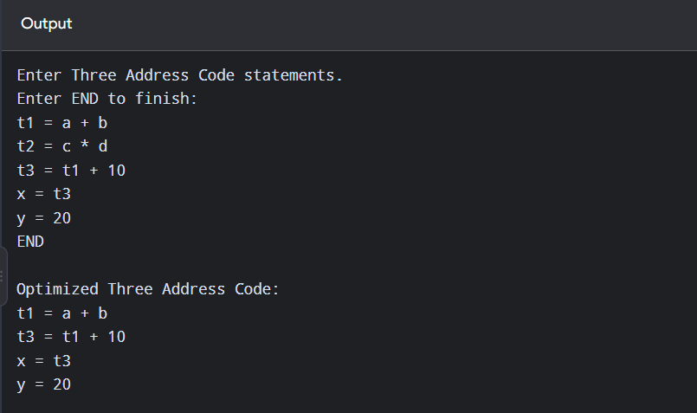
Result
Thus, the C program to identify and eliminate dead code from a given sequence of Three Address Code statements was implemented successfully, and the optimized code was displayed.

